|  |  |
| --- | --- |
| Critical Information Summary | |
| Student Name | * Bobby Putra * Dennis Darwis |
| SID | * Bobby – 215339949 * Dennis –216280619 |
| Mark Aimed For (%) | 90% |

### Criteria: Code commits GitHub [HD]

* We put clear description on every commit.
* We made different branch for the app release.

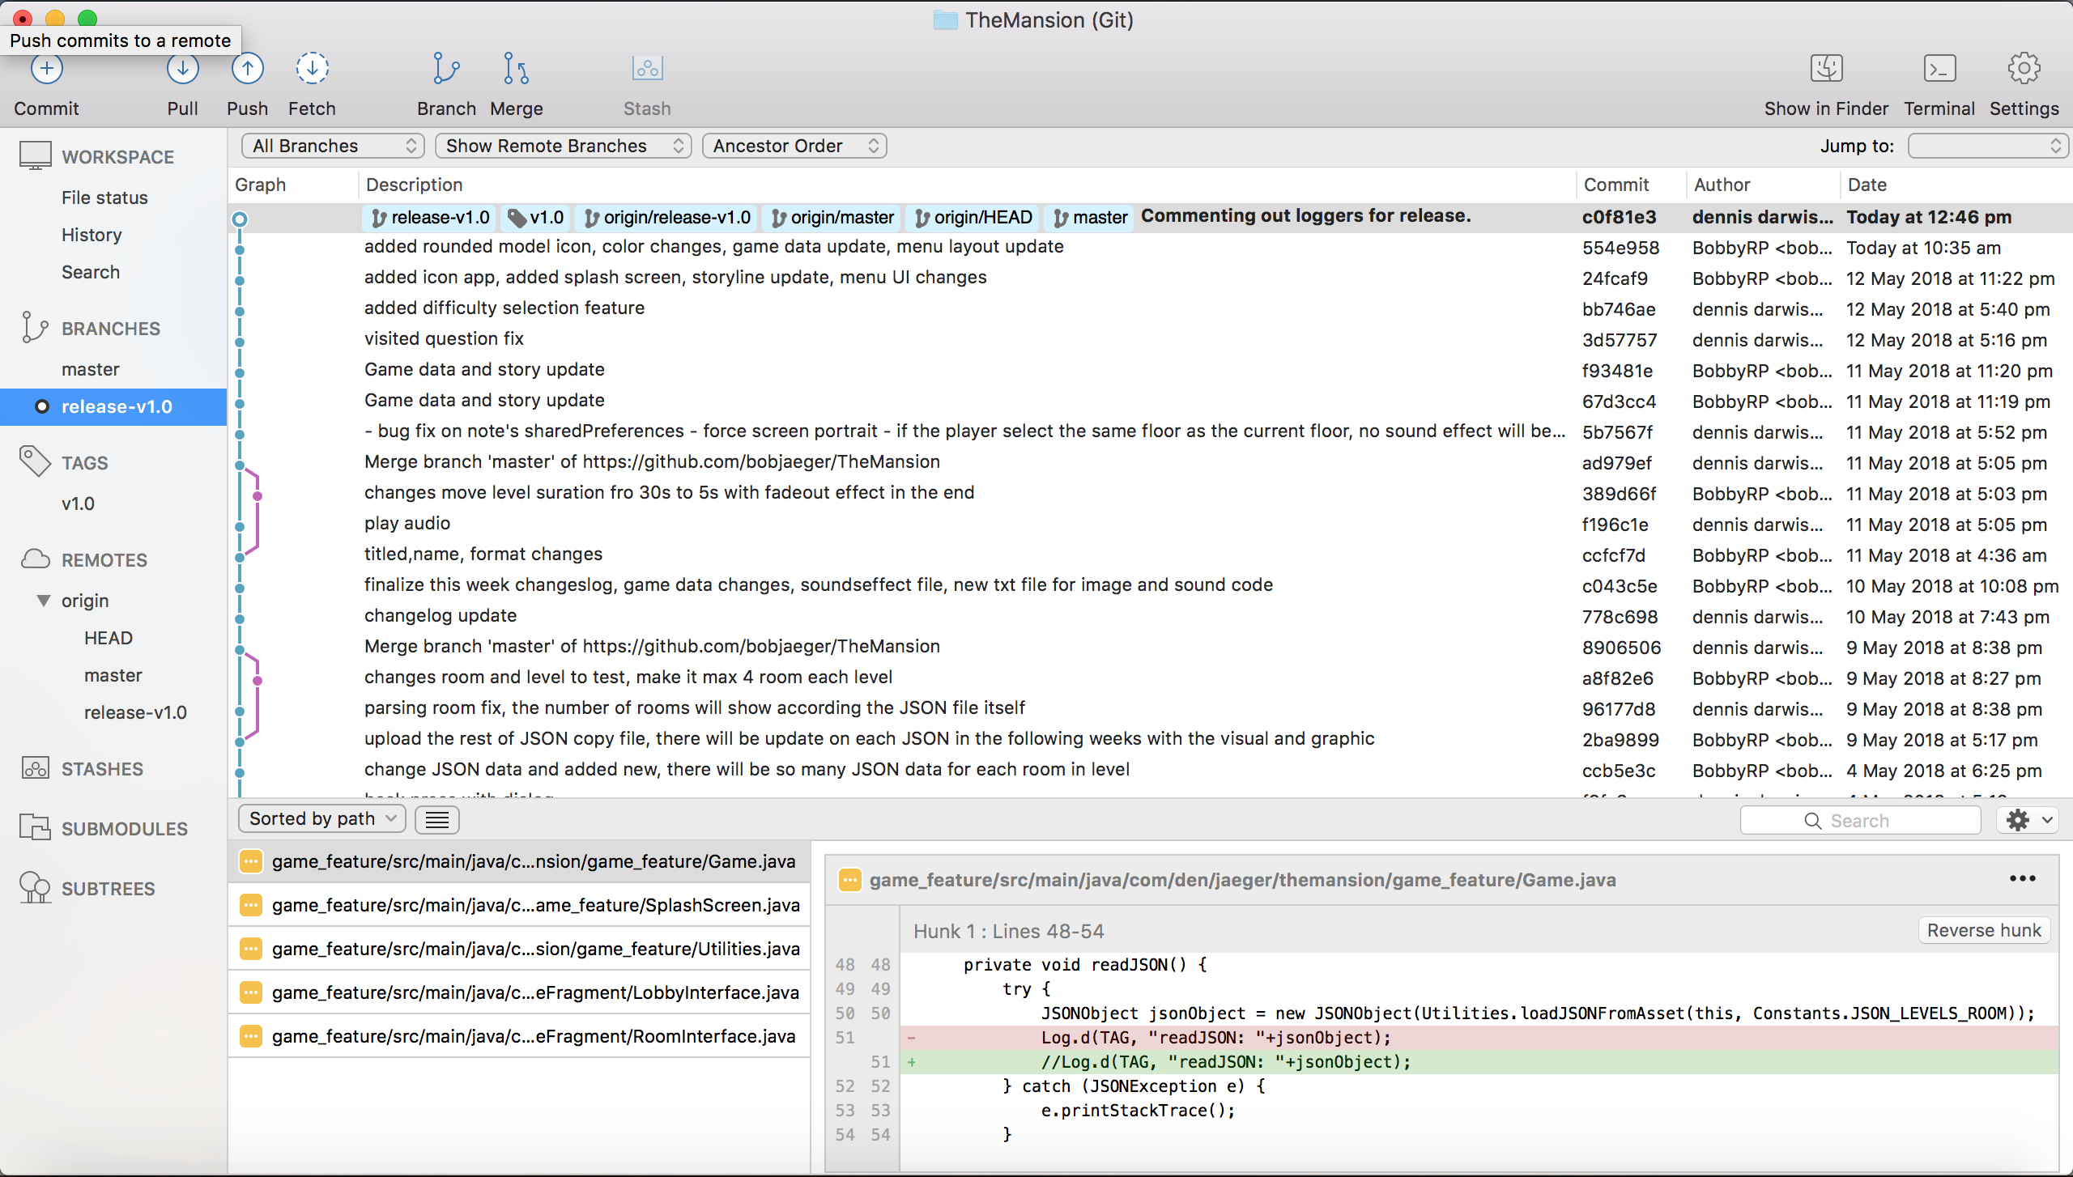

### Criteria: Weekly progress [Distinction]

* We worked productively every week.
* Changelog properly updated every week.
* You can see the our changelog.txt inside the project, that we state **activity** for the week, our **roadblock** while work on the project, and what our **next plan**

### Criteria: Code quality [Distinction]

* Code refactored properly.
* Implemented Static variables for common variables.
* Implemented class that contains common functions/methods.
* Readable code.

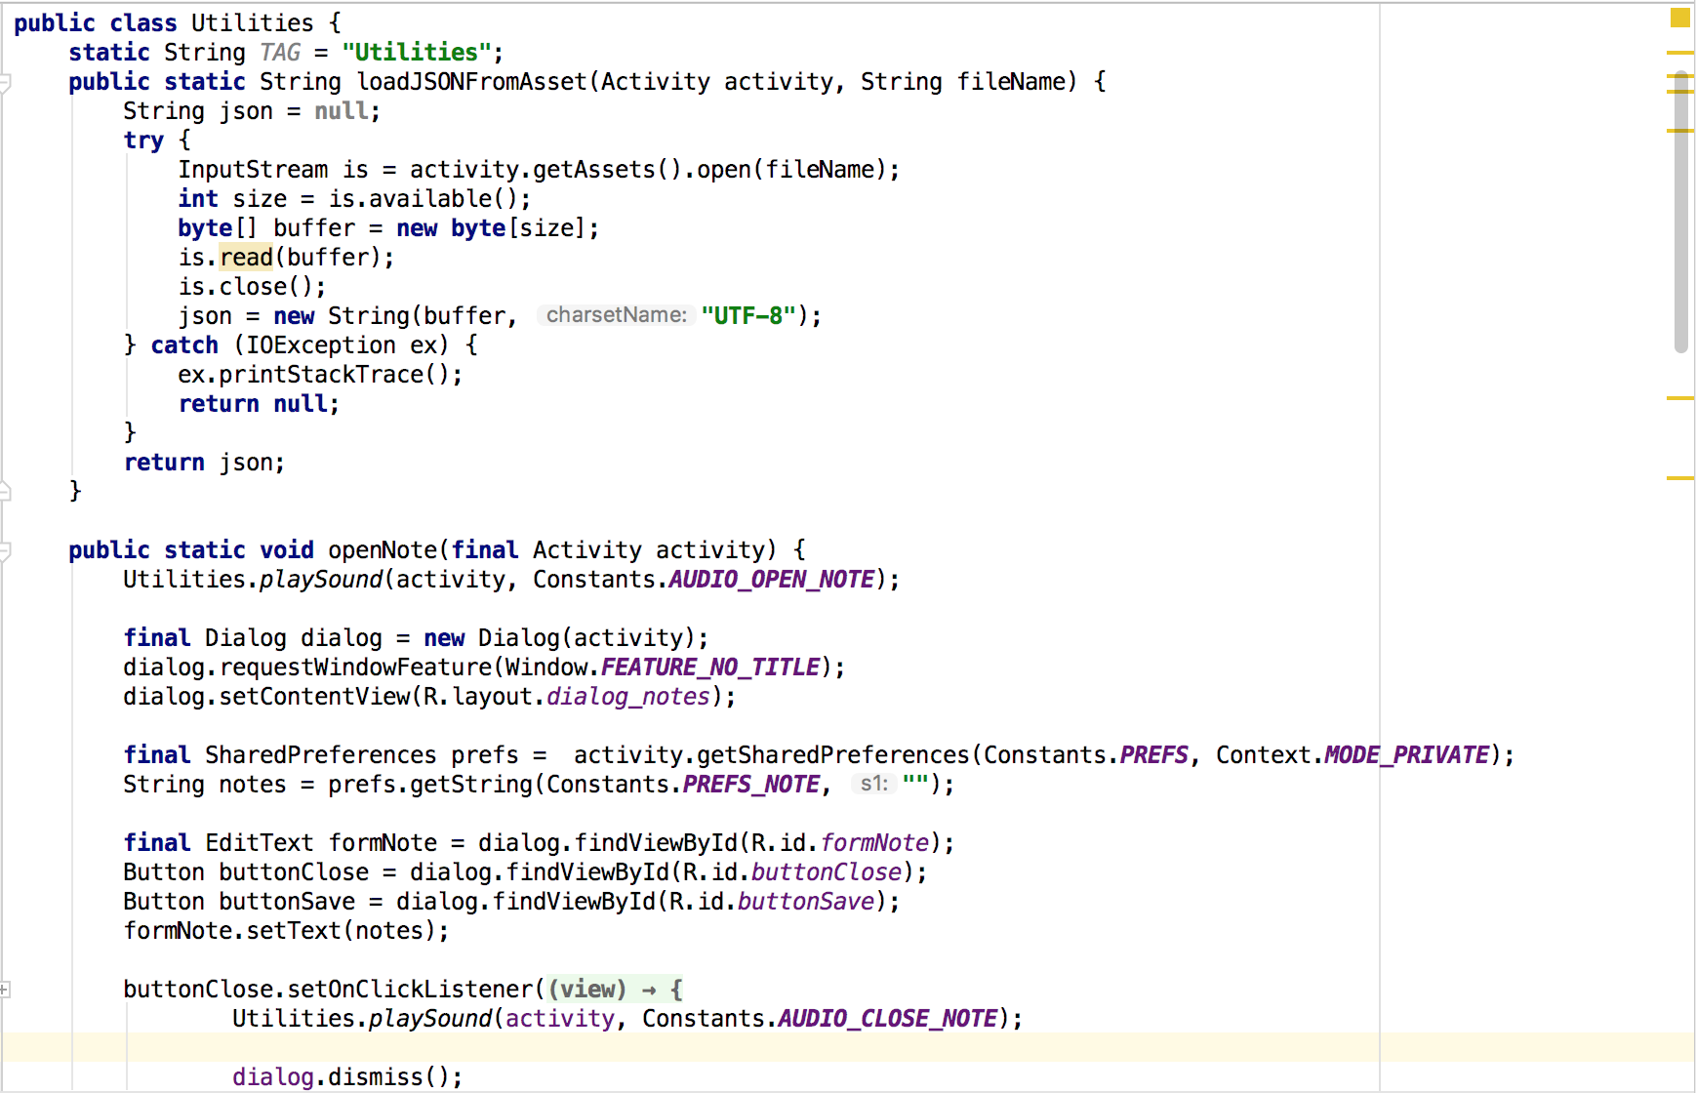

Figure 1: Utilities class that contains functions/methods that are commonly used.

### Criteria: Legal [Distinction]

* Hyperlinks to the source page written.
* Attributions made by give all the details inside the license.txt
* We put all the details for the visual and audio file that we put in the project.

### Criteria: Playability [Distinction]

* Various levels made.
* Each levels contains puzzles and obstacles.
* And player have a life points that need to keep in mind.

### Criteria: Data Handling [HD]

* Levels and Questions are stored on external JSON file
* High Score stored in SQLite database.
* Game state (user's life number, current floor, explored rooms, etc.)

### Criteria: Layout [Distinction]

* Application restricted only for portrait, so even though the phone rotation is enabled.
* We have to keep our app game in portrait mode because we have our own reason to keep it on portrait mode, lesson learned from others project we do in the university about landscape for a game that require it.
* It can adjust the UI object if there changes on phone size (portrait mode).

### Criteria: Bugs[Credit]

* Bugs handled and the fixed bugs are pushed to the repository with description.
* We try to handle the bugs before with give player a notification about what player want to do before player spam the functions.

### Criteria: Readme.md [HD]

* API References.
* Game Description.
* Includes explanation of the features.
* It’s well written on readme that displayed at our GitHub page.

### Criteria: Publishing [HD]

* App is published to the Android Play Store link here - <https://play.google.com/store/apps/details?id=com.den.jaeger.themansion>
* App meets the App Store guidelines
* App has icons, screenshot, video
* We put publishing asset inside our project directory.

### Criteria: Demonstration Video [Distinction]

* Video well described how to play the game and feature that the game has.
* Explanation how to utilize the feature
* Guide to play the game
* Uploaded to YouTube link here - <https://www.youtube.com/watch?v=KoMgM7OJbug&feature=youtu.be>